**FULL SUBTRACTOR**  
**EXP.NO: 24**

**AIM:**To design and implement the full subtractor using Logisim simulator. 

**PROCEDURE:**  
1)      Pick and place the necessary gates.   
2)      Insert 3 inputs into the canvas.   
3)      Connect the inputs to the XOR gate, AND gate and OR gate.  
4)      Insert 2 outputs into the canvas.  
5)      Make the connections using the connecting wires.  
6)      Verify the truth table.

**TRUTH TABLE:**  
  
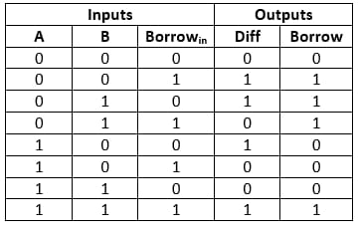  
  
  
Diff=(A ⊕ B) ⊕ 'Borrowin'  
  
Borrow=A'.B + (A ⊕ B)'  
  
**OUTPUT:**  
  
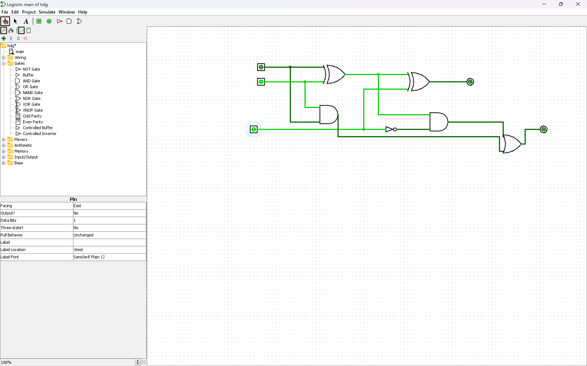  
 

**RESULT:**

Thus full subtractor has been designed and implemented successfully using logisim simulator.